# **HTML ASSIGNMENT**

* Student Number and Names: C19478224, Maija Soares

C18493372, Sean Browne

C19461872, Matthew Hurley

C19329516, Hilary Nwajei

* Each student in the group should be responsible for the creation of three HTML pages
* Assignment due date: 26th April 2020

**Chosen Company** Valve Corporation

* [Valve Corportation Official Website](https://www.valvesoftware.com/)

|  |  |
| --- | --- |
| **Page** | **Assigned to: (name)** |
| Homepage | Assigned to; Maija Soares, C19478224 |
| About page | Assigned to; Sean Browne, C18493372 |
| Services (if the company has any) | Assigned to; Sean Browne, C18493372 |
| Products (if the company has any) | Assigned to; Sean Browne, C18493372 |
| FAQ page | Assigned to; Maija Soares, C19478224 |
| Review page | Assigned to; Matthew Hurley, C19461872 |
| Contact page | Assigned to; Matthew Hurley, C19461872 |
| News page /the latest | Assigned to; Matthew Hurley, C19461872 |
| Privacy policy page | Assigned to; Maija Soares, C19478224 |
| Terms and conditions page | Assigned to; Hilary Nwajei, C19329516 |
| Page not found page | Assigned to; Hilary Nwajei, C19329516 |
| Jobs or careers page | Assigned to; Hilary Nwajei, C19329516 |

Stylesheet/Website Layout: assigned to; Maija Soares, C19478224

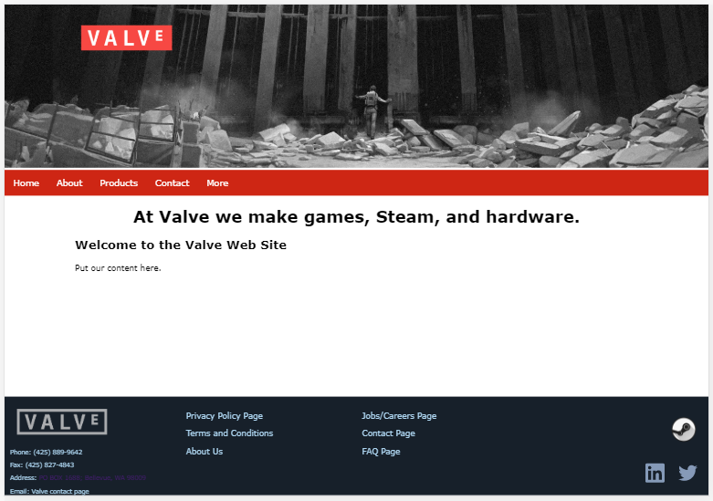

***Website layout without content***

*Assigned to; Maija Soares, C19478224*

* When creating the website template, I used Google's chrome emulator to test how mobile responsive the template was.
* *The top of the website is a banner with Valve’s logo and an image from their newest game ‘Half-Life: Alyx’. I used photoshop layer to merge the corporate logo with the background that I chose. I then optimised the jpg for web use.*
* *Beneath the websites banner is an index of the main pages within the company's website (Home, About, Products, Contact). The last entry in the index ‘More’ is a drop-down menu that shows more pages within the website (Steam, FAQ, Reviews, News and Jobs).*
* *Below the index is the content of the specified page.*
* *The bottom of the website is the footer. The footer is separated into 4 columns. The first column contains Valve’s logo with their contact information below (Phone no., Fax, Address and Email). The second and third column contains links to other pages within the website (Privacy Policy Page and Terms and Conditions are only linked in the footer). The fourth column contains images that are linked and when clicked goes to Valve’s LinkedIn, Twitter and Steam.*

# **Contents of each page**

* **Homepage**

*Assigned to; Maija Soares, C19478224*

A websites starting point is its home page. It is the default webpage that loads when you visit a web address that only contains a domain name. In this page, a short reference paragraph is made about the main pages of this website and has a 'Find out more' button that when clicked, takes the user to the specified page. The page also contains quick updates such as releases and projects in the works.

* **About page**

*Assigned to; Sean Browne, C18493372*

This page is used to show basic information about the company. It includes the basic history of the company as well as some modern history to shed some light on their current projects it utilizes gifs and video to add imagery to the page to split the text and make it easier on the eye.

* **Services (if the company has any)**

*Assigned to; Sean Browne, C18493372*

Services page focuses on Steam valves game distribution service which they have developed in a much bigger entity since its creation in 2003 it goes into detail on the numerous different aspects of steam. From VR to their personalized workshop it also links steams website via a highlighted reference as well as a gif u can use to access the page as well.

* **Products (if the company has any)**

*Assigned to; Sean Browne, C18493372*

This focuses on some of the games released by valve over the course of their creation since 1996. It displays 6 iconic games they have created and then it goes on to show their VR products with a video trailer of the VR system they have produced in recent years the webpage uses highlighted referencing to bring users who visit the site to locations where they can find out more about the various products displayed on the page.

* **FAQ page**

*Assigned to; Maija Soares, C19478224*

A FAQ page is a page that poses a series of common questions and answers on a specific topic. This page contains frequently asked questions about Valve’s upcoming and most popular games. The questions are displayed in boxes and when clicked the answer appears beneath the box. I used dynamic drop downs to make it easier to browse and view with the various questions.

* **Review page**

*Assigned to; Matthew Hurley, C19461872*

This page displays 7 great valve games from across the years and shows the consistency of how great valve’s games are giving 3 scores per game from the time of its release. Each game is followed by its appropriate image for easy recognition.

* **Contact page**

*Assigned to; Matthew Hurley, C19461872*

The contacts page will have contact details for valve as well as press inquiries information and a basic idea of the company's structure with no bosses and more teamwork.

* **News page /the latest**

*Assigned to; Matthew Hurley, C19461872*

The news page has the latest news stories involving valve to keep viewers up to date with the latest valve has to offer. This includes news of their latest competition, their newest game and their newest broken records during this global pandemic.

* **Privacy policy page**

*Assigned to; Maija Soares, C19478224*

A privacy policy page displays Valve's legal document that discloses some or all the ways a party gathers, uses, discloses, and manages a customer or client's data. In this page, any reference made to other pages, other websites and sections within the page is linked so that when clicked it arrives at that destination.

* **Terms and conditions page**

*Assigned to; Hilary Nwajei, C19329516*

This focuses on the agreement that sets the rules and guidelines that users must agree to and follow in order to use and access the website.

* **Page not found page**

*Assigned to; Hilary Nwajei, C19329516*

The page not found appears when user searches for something that does not exist on the website you have created. If done creatively the 404 page can entice the user to stay on your website.

* **Jobs or careers page**

*Assigned to; Hilary Nwajei, C19329516*

This page shows all the users all the available jobs that are vacant. The user can then choose which job opening is suited for them and apply for it.